BRAINWARE UNIVERSITY
PYTHON PROJECT-BASED LEARNING REPORT (WEEK 3)

1. Basic Information
Title of the Project: | Employee Management System & Library Management System
Programs Covered: | Program 1: Employee Management System  Program 2: Library Management System
Name(s) of Student(s): | Soumyadwip Das (BWU/BTS/25/169)  Ankita Paul (BWU/BTS/25/180)  Sonia Naskar (BWU/BTS/25/195)  Joyeta Mondal (BWU/BTS/25/214)  Sayantan Bharati (BWU/BTS/25/503)
Programme & Semester: | B.Tech CSE & 3rd Semester
Course Name & Code: | Python Programming Lab (BES09013)
Name of the Guide/Supervisor: | MR. PRANAB GHARAI & MR. INDRANIL DAS
Project Date | 14/08/2026



2. Introduction and Background

Week 6 covers two console-based CRUD systems: an Employee Management System and a Library Management System. Both use dictionaries, validation, unique IDs, and menu-driven operations.

3. Objectives of the Project (Week 6)
Program 1 - Employee Management System
- Create a console-based employee management system.
- Generate unique employee IDs using random.
- Validate employee name, department, and salary.
- Implement add, update, delete, search, and list operations.
- Test valid and invalid inputs.
Program 2 - Library Management System
- Manage members, books, and issue/return records.
- Generate unique IDs for members, books, and issues.
- Validate member email and phone details.
- Implement member and book management.
- Prevent double-issuing books and deleting members with active loans.
4. Problem Statement / Driving Question
Program 1: How can employee records be managed with unique IDs and valid inputs?
Program 2: How can members, books, and loans be managed while preventing invalid operations?

5. Methodology (Week 6 Activities)
Program 1 - Employee Management System
- Reused box-drawing functions for the interface.
- Created a random, collision-free employee ID generator.
- Added validation for name, department, and salary.
- Implemented add, update, delete, search, and list functions.
- Tested invalid department and salary inputs.
Program 2 - Library Management System
- Reused the boxed interface and menu structure.
- Created a shared unique-ID generator for members, books, and issues.
- Added validation for member name, email, and phone.
- Implemented member and book management.
- Used a separate ISSUED dictionary for loan records.
- Prevented double-issuing books and deleting members with active loans.

6. Expected Outcomes / Deliverables (Week 6)
- Working Employee Management System with CRUD operations.
- Working Library Management System with member, book, and loan management.
- Validated input for required fields.
- Safeguards against invalid library operations.
- Consistent boxed console interfaces.
- Future improvements: file/database storage and due-date tracking.

7. Core Logic & Output (Program 1)
Program 1 - Unique ID Generation and Record Deletion
- generate_id() creates a unique random employee ID.
- delete_employee() checks if the employee exists before deleting.
def generate_id():
"""Generate a unique 4-digit employee ID, e.g. E1234."""
while True:
emp_id = "E" + str(random.randint(1000, 9999))
if emp_id not in EMPLOYEES:
return emp_id # retry until a unique ID is found

def delete_employee(emp_id):
if emp_id not in EMPLOYEES:
print_boxed(["Employee not found."])
return
name = EMPLOYEES[emp_id]['name']
del EMPLOYEES[emp_id] # remove the record from memory

Program 1 - Employee Management System
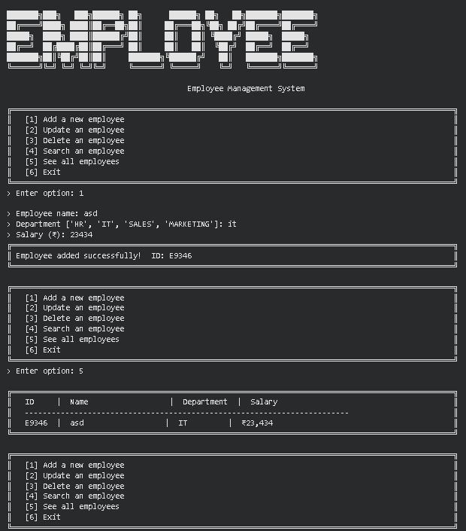

8. Core Logic & Output (Program 2)

Program 2 - Shared ID Generation and Issue Records
- generate_id(prefix) creates unique IDs for members, books, and issues.
- issue_book() prevents duplicate issues and creates a separate loan record.
def generate_id(prefix):
"""Generate a unique ID like B1234, M5678, I9012."""
while True:
new_id = prefix + str(random.randint(1000, 9999))
if new_id not in BOOKS and new_id not in MEMBERS and new_id not in ISSUED:
return new_id # unique across all three record types

def issue_book():
book_id = input("> Enter book ID: ").strip().upper()
if any(r["book_id"] == book_id for r in ISSUED.values()):
print_boxed(["ERROR: Book is already issued."])
return
member_id = input("> Enter member ID: ").strip().upper()
issue_id = generate_id("I")
ISSUED[issue_id] = {"book_id": book_id, "member": member_id} # new issue record
Program 2 - Library Management System
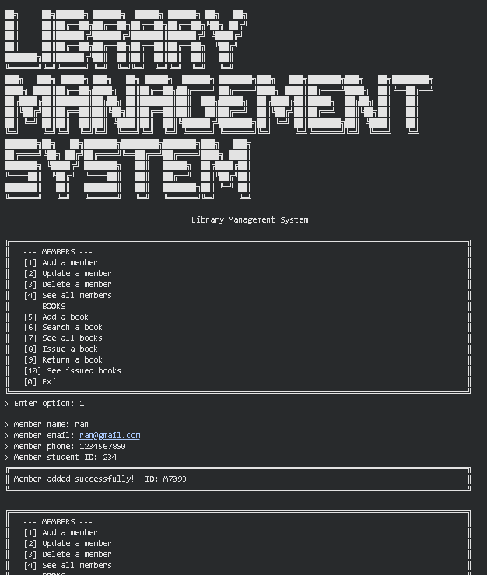

10. Tools & Technologies Used
Tool / Technology | Purpose
Python 3.x | Core programming language used to implement both console systems
Python Dictionaries | In-memory storage of employees, members, books, and issue records, each keyed by a unique ID
random module | Generating unique, prefix-based IDs for employees, members, books, and issue records
Input Validation Loops | Re-prompting until a valid department/salary, or a valid member email/phone, is provided
String Formatting (f-strings) | Rendering aligned tabular listings of employees, members, books, and issued loans
Functions & Control Flow | Modularising add/update/delete/search/issue/return operations across both systems

11. References
- Python Official Documentation: https://docs.python.org/3/
- Python random module Reference: https://docs.python.org/3/library/random.html
- Python Dictionaries - Data Structures Guide: https://docs.python.org/3/tutorial/datastructures.html
- Brainware University - Machine Learning Course Guidelines

12. Signatures
Signature of Student(s): Date of Submission:

Signature of Guide/Supervisor:

